EXPERIMENT ASSESSMENT
ACADEMIC YEAR 2025-26

Course: Multidisciplinary Minor

Course code: MDC401

Year: SE SEM: IV

Experiment No. 3
AIM Create a dynamic To-Do List where users can add, mark as complete, and remove tasks using JavaScript & DOM.
Name: Ashish Ramesh Patel
Roll Number: 55
Date of Performance:
Date of Submission:

Evaluation
Performance Indicator | Max. Marks | Marks Obtained
Performance | 5
Understanding | 5
Journal work and timely submission. | 10
Total | 20

Performance Indicator | Exceed Expectations (EE) | Meet Expectations (ME) | Below Expectations (BE)
Performance | 5 | 3 | 2
Understanding | 5 | 3 | 2
Journal work and timely submission. | 10 | 8 | 4

Checked by

Name of Faculty : Dr. Yogesh Pingle

Aim: Create a dynamic To-Do List where users can add, mark as complete, and remove tasks using JavaScript & DOM.

Theory
- A To-Do List application is a basic yet powerful example of a dynamic web application. It allows users to manage daily tasks by adding new tasks, marking tasks as completed, and removing tasks when they are no longer required. Such applications demonstrate the use of client-side scripting and real-time interaction without reloading the web page.
- The To-Do List application uses HTML for structure, CSS for presentation, and JavaScript for dynamic behavior. JavaScript interacts with the web page through the Document Object Model (DOM), making the page responsive to user actions.
- HTML (HyperText Markup Language)
HTML is used to define the basic structure of the To-Do List application. It provides elements such as input fields, buttons, lists, and containers that form the user interface. In a To-Do List:
- Input elements are used to accept task details from the user
- Buttons are used to trigger actions like add or delete
- List elements are used to display tasks
Semantic HTML elements improve readability, accessibility, and maintainability of the application.
- CSS (Cascading Style Sheets)
CSS is used to enhance the visual appearance of the To-Do List. It controls layout, colors, fonts, spacing, and alignment. CSS is also used to visually distinguish completed tasks, for example by applying a strike-through effect or changing text color. Proper styling improves user experience and clarity.
- JavaScript
JavaScript is a client-side scripting language used to make web pages interactive. In a dynamic To-Do List application, JavaScript performs the following roles:
Captures user input
Handles user events such as button clicks
Updates the task list dynamically
Applies logic for task completion and deletion
JavaScript enables changes to occur instantly without refreshing the page.

- Document Object Model (DOM)
The Document Object Model (DOM) is a programming interface that represents an HTML document as a tree-like structure of objects. Each HTML element becomes a node in the DOM. JavaScript can access and manipulate these nodes to dynamically change the content and structure of a web page.
In a To-Do List application, DOM manipulation is used to:
- Create new task elements dynamically
- Insert tasks into the list
- Modify task appearance when marked as complete
- Remove tasks from the list
- Event Handling
Events are actions performed by the user such as clicking a button, typing text, or selecting an option. JavaScript uses event listeners to detect and respond to these actions.
In the To-Do List application:
Clicking the “Add” button triggers task creation
Clicking a checkbox or task marks it as completed
Clicking a delete button removes the task
Event handling is essential for creating interactive applications.
- Dynamic Task Management
The dynamic nature of the To-Do List means that tasks are managed at runtime. Tasks are added, updated, or removed directly in the DOM.
This allows:
  - Immediate visual feedback
  - Efficient task handling
  - Improved performance compared to page reloads
  - Each task is treated as an independent DOM element, making management simple and scalable.
- Task Completion Feature
Marking a task as complete is an important feature of a To-Do List. This is achieved by updating the task’s state using JavaScript and modifying its visual style using CSS. Completed tasks help users track progress and organize their work efficiently.
- Task Removal Feature
The task removal feature allows users to delete unwanted or completed tasks. JavaScript removes the corresponding DOM element from the task list. This operation demonstrates effective DOM manipulation and memory management on the client side.

Procedure :
- Create HTML structure:
- <input id="task" type="text">
<button onclick="addTask()">Add</button>
<ul id="list"></ul>
- Write JavaScript:
- <script>
function addTask() {
let task = document.getElementById('task').value;
let li = document.createElement('li');
li.innerText = task;
li.onclick = () => li.remove();
document.getElementById('list').appendChild(li);
}
</script>
- Save and run in browser.

Code :
Index.html
<!DOCTYPE html>
<html lang="en">
<head>
<meta charset="UTF-8">
<meta name="viewport" content="width=device-width, initial-scale=1.0">
<title>Dynamic To-DO List</title>
<link rel="stylesheet" href="style.css">
</head>
<body>
<div class="conatiner">
<h2>To-Do List</h2>
<div class="input-box">
<input type="text" id="taskInput" placeholder="Enter a task">
<button onclick="addTask()">ADD</button>
</div>
<ul id="taskList"></ul>
</div>

<script src="script.js"></script>
</body>
</html>
Style.css
body{
font-size: Arial,sans-serif; background: #f4f4f4;
display: flex; justify-content: center; align-items: center; height: 100vh;
}
.todo-container
{
background: white; padding: 20px; width: 300px; border-radius: 8px; box-shadow: 0 0 10px rgba(0,0,0,0.1);
}
.input-box
{
display: flex;
gap:5px;
}
input
{ flex: 1;
padding: 8px;
}
button
{
padding: 8px; background: #28a745;
color: white; border: none; cursor: pointer;
}
button:hover
{
background: #218838;
} ul
{
list-style:none ; padding: 0; margin-top:15px;
}
li
{
display: flex;
justify-content: space-between; padding: 8px; background: #eee; margin-bottom:5px;
cursor: pointer;
}
li.completed
{
text-decoration: line-through;
color: gray;
}
.delete
{
background: red; color:white; border: none; padding: 3px 6px; cursor: pointer;
}
Script.js

function addTask(){ const taskInput =document.getElementById("taskInput"); const taskText =taskInput.value.trim();
if(taskText==="")
{
alert("Please enter a task");
}
const li=document.createElement("li"); li.textContent=taskText;

li.addEventListener("click",function()
{
li.classList.toggle("completed");
});

const deleteBtn=document.createElement("button"); deleteBtn.textContent="X"; deleteBtn.className="delete";

deleteBtn.addEventListener("click",function(e)
{
e.stopPropagation(); li.remove();
});

li.appendChild(deleteBtn); document.getElementById("taskList").appendChild(li);
taskInput.value="";
}

Output
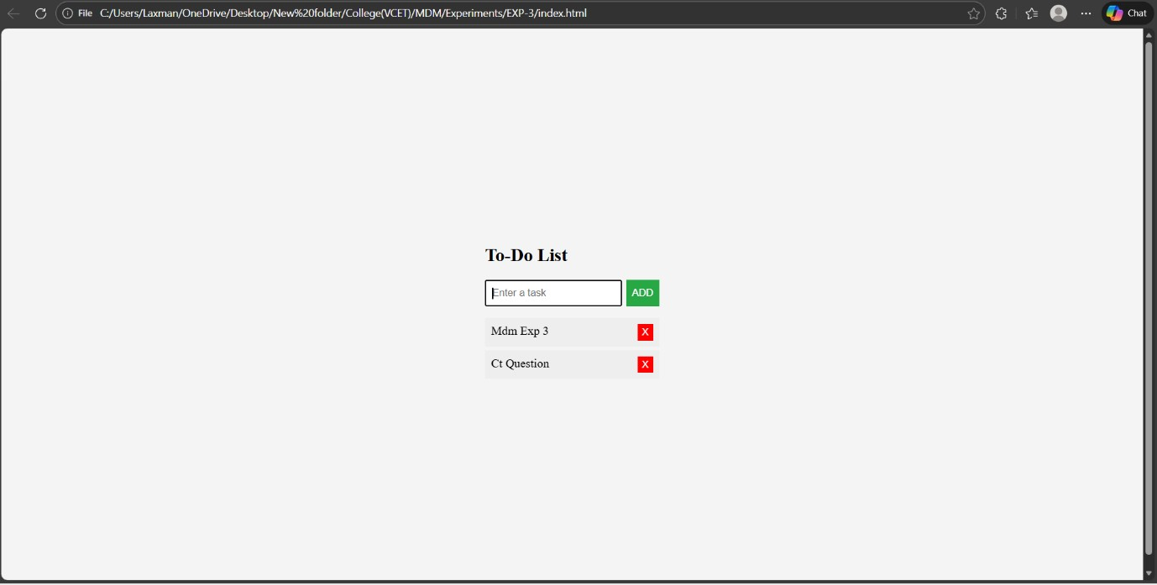

Conclusion:
The dynamic To-Do List was successfully implemented using JavaScript and DOM manipulation. Users can add new tasks, mark tasks as complete, and delete tasks in real-time without page reload. The project demonstrates the use of event handling, array management, and dynamic HTML updates, providing practical understanding of interactive web applications.
Questions:
1.What is an event listener? Give an example.
Ans:
Definition: An event listener is a procedure in JavaScript that waits for an event (like click, keypress, hover) to occur on an element and executes a function in response.
Example:
Javascript:

document.getElementById("btn").addEventListener("click", function() {
alert("Button clicked!");
});

Key Points:
- Used to handle user interactions dynamically.
- Can be attached to HTML elements.
- Supports multiple event types (click, input, mouseover, etc.).

2. What is the difference between innerHTML and textContent?
Ans:
Aspect | innerHTML | textContent
Definition | Returns/sets HTML content inside an element | Returns/sets only text content inside element
HTML Tags | Parses and renders HTML tags | Treats tags as plain text
Use Case | When you need to insert HTML markup dynamically | When you only need raw text
Example | element.innerHTML = "<b>Hello</b>"; → bold text | element.textContent = "<b>Hello</b>"; → shows <b>Hello</b> literally

3.What is the difference between synchronous and asynchronous JavaScript in this context?
Ans:
Aspect | Synchronous JavaScript | Asynchronous JavaScript
Definition | Executes code line by line, blocking further tasks | Executes tasks without blocking main thread
Execution Flow | Next statement waits until current finishes | Allows other operations while task completes
Example | alert("Hello"); console.log("World"); → waits | setTimeout(()=>console.log("World"),1000);
Use Case | Simple, sequential tasks | API calls, timers, event handling, promises

